|  |
| --- |
| Circle Language Spec: Commands |

## Commands Anywhere in a Diagram

The article *Commands Anywhere* explained the concept of commands being able to freely move around. In the current article, the idea is further clarified with diagrams.

You can put the executable object inside another object:



You can reference an executable object:

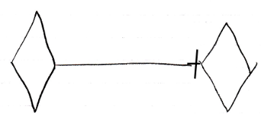

Yes, you can put an executable object inside a command definition:

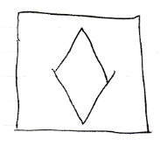

But you can also put an executable object inside a class:



You can run an execution inside an object, sort of like having an execution run inside a specific folder:

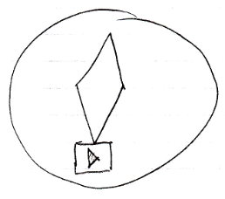

You can also run the execution inside your user object and sort of take it along with you, whereever you go into the digital world.

You can also run an execution globally on a site.

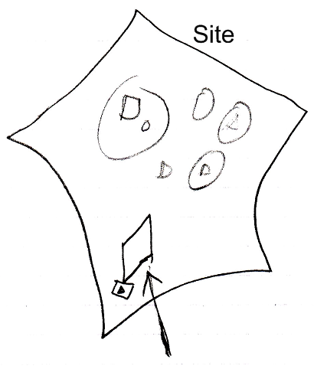

Executions can also be placed in a list. No problem. You can run each item in the list individually.

